**Joint Document: Review of Codal Provisions for OSP & Site Parking Data Analysis**

**Table of Contents**

List of Tables………………………………………………………………………………………………………………………………………3  
List of Figures…………………………………………………………………………………………………………………………………….3

**Part 1: Codal Review**

Chapter 1.1 Provisions for OSPs: A summary

* Section 1.1.1 Executive Summary………………………………………………………………………………………….4
* Section 1.1.2 Important Definitions……………………………………………………………………………………….4

Chapter 1.2 Review of Codal provisions

* Section 1.2.1 Classifications of Roads/Streets and restrictions thereof………………………………….5
* Section 1.2.2 Other restrictions…………………………………………………………………………………………….6
* Section 1.2.3 Site specific design considerations……………………………………………………………………7

Chapter 1.3 Gaps identified

* Section 1.3.1 Gaps in codal provisions…………………………………………………………………………….......9

**Part 2: Parking Data Analysis**

Chapter 2.1 Preliminary analysis

* Section 2.1.1 Observations…………………………………………………………………………………………….......10

Chapter 2.2 Phool Bagh Parking Analysis

* Section 2.2.1 Robustness……………………………………………………………………………………………….......11
* Section 2.2.2 Exploratory Analysis………………………………………………………………………………......…15

Chapter 2.3 Regency Hospital Parking Analysis

* Section 2.3.1 Robustness……………………………………………………………………………………………….......19
* Section 2.3.2 Exploratory Analysis………………………………………………………………………………......…23

**Inputs from KSCL**……….......……………………………………………….………….………………………….….………………….27

**References**…………………...…………………………………………………………………………………………………………………27

**List of Tables**

1. Classification and restrictions for the presence of On-Street Parking on street functional classes.......................................................................................................................................6
2. Summary of Spot design...........................................................................................................8
3. How often has a particular type of transaction happened – (Phool Bagh)?............................16
4. How often a particular type of transaction happened – (Regency Hospital)?.........................25

**List of Figures**

**Data Examples**

* Examples of missing exit time information………………………………………………………………………….11
* Non-unique identification of two and four wheelers…………………………………………………………..12
* Overlapping entries for the vehicle ID…………………………………………………………………………………12
* Mismatch in amount charged……………………………………………………………………………………………..13
* Examples of mismatch in expected and observed amounts…………………………………………………13
* Instances of transactions at the intersection of 5 minutes…………………………………………………..13
* Inconsistency in application of `*DoNotCountMinutes`…………………………………………………………*14
* Instance of `*MutilatedOrUnreadableTicketTransaction*`………………………………………………………14
* Inconsistency in dates across columns – 1…………………………………………………………………………..14
* More examples of inconsistency in dates across columns……………………………………………………14
* Examples of missing exit time information – 2…………………………………………………………………….19
* Examples of missing vehicle type…………………………………………………………………………………………19
* Exit time before entry time………………………………………………………………………………………………….20
* Non-uniqueness of vehicle type………………………………………………………………………………………….20
* Overlapping parked times……………………………………………………………………………………………………21
* Inconsistency in amount charged………………………………………………………………………..………………21
* Other instances of mismatch in transaction amounts………………………………………………………….22
* Inconsistent transaction amounts for 5-minute durations……………………………………………………22
* Marking of `*DoNotCountTicket`………………………………………………………………..…………*………………22
* Inconsistency in dates across columns – 2…………………………………………………………………………..23
* Another example of inconsistency in dates across columns…………………………………………………23

**Visualizations**

* Temporal Distribution of parking events..................................................................................16
* Duration of parked vehicles.....................................................................................................17
* Durations of Parked time (log scale) .......................................................................................18
* Average duration of time parked across months – 1...............................................................18
* Temporal trends in parking events...........................................................................................24
* Distributions of time parked....................................................................................................25
* Distributions of time parked (in log scale) ..............................................................................26
* Average duration of time parked across months – 2...............................................................26

**Part 1 Codal Review**

**Chapter 1.1 Provisions for On-Street Parking: A Summary**

**1.1.1 Executive Summary**

This study reviews the selection criteria and design practices for on-street parking sites according to guidelines and design handbooks issued by governmental (e.g. Indian Roads Congress (IRC)) and non-governmental agencies (e.g. Institute for Transportation and Development Policy (ITDP)).

The summarized guidelines and design principles have been arranged in a top-down approach as selection of streets, exclusion of locations based on street features, design of site and design of spot. Quantifiable design and classification criteria have been highlighted throughout each section. Section specific criteria have been tabulated. Various gaps in the current codal provisions have been identified based on lack of quantifiability, specificity of guidelines, applicability, and verifiability.

Finally, please note that these codal provisions have not been evaluated for the consistency of recommendations with findings with the academic literature, which will be reviewed as part of the next steps.

**1.1.2 Important Definitions**

In this study, we shall review the guidelines pertaining to parking activity on Indian streets as per publications from IRC (and ITDP).

The various terms used in this study are defined as follows:

* **Parking activity:** Parking is an act of stopping and disengaging a vehicle and leaving it unoccupied. (IRC: SP:12-2015 2.1)
* **OSP: On-street Parking:** Parking on road/street generally in Urban Local
* Bodies limits.
* **CW: Carriageway width:** Space on the road available for the traffic to traverse.
* **ULB: Urban Local Body:** The governmental body which is the local decision-making body for the specific city or town. E.g. Mahanagar Nigam, Nagar Palika and so on.
* Moreover, we shall use the terms ‘restricted’ in the manner that *X* is restricted if:
* *X* is generally not permitted to occur in situation *Y*.
* In certain clearly defined sub-cases of *Y, X* is allowed to occur.

**Chapter 1.2 Review of Codal provisions**

**1.2.1 Classifications of Roads/Streets and restrictions thereof**

For this study, the expressways, and streets for non-motorized transport (NMT), such as cycle lanes, have been excluded due to their relevance to the jurisdictions of interest within the Kanpur Smart City study. With that, let us define and characterize the permissibility of OSPs on the 4 categories of roads.

***Arterial Road:***

* A general term denoting a road/street primarily for through traffic, usually on a continuous route,
* facilitating mobility across the city.
* It typically connects to long distance destinations within/outside the city and provides safe NMT facilities.
* Features: (IRC:86-2018 table 4.1)
* Land width of 45-60 m for plain terrain.
* Design speed limits of 60 kmph (plain terrain).
* Parking activities are restricted, except in case of the presence of a suitable service lane. [2, 4, 5]
* OSP is restricted if carriageway width is less than 7.25 m.
* For example, for a 4-lane road, the total carriageway may not be less than 14.5 m for OSP to be permitted [3]. (>14 m as recommended by IRC:86).
  + 1. ***Sub-Arterial Road:***
* offers a somewhat lower level of traffic mobility than the arterial road.
* These are larger ‘collector streets’ meant for movement through neighbourhoods and to connect to arterial roads.
* Features:
* Land width of 30-45 m (plain terrain).
* Design speed limits of 60 kmph.
* OSP is restricted if CW is less than 7.5 m. [3]
* Hence for a 4-lane road, A total CW of 15 m will be required for OSP to be permitted. (>14 as per IRC:86)
  + 1. ***Collector Street:***
* A street for collecting and distributing traffic from and to local streets and for providing access to arterial/sub arterial roads.
* Features:
* Land width of 15-30 m (plain terrain).
* Design speed limits of 40 kmph.
* OSP can be provided [4, 5] requiring that CW exceeds 5.5 m. [3]
* Hence for a four-lane collector street, total required CW shall be 11 m (<14 m design CW). Hence OSP is generally permissible.
  + 1. ***Local Street:***
* A street primarily for access to residence, business, or other abutting property.
* Its primary function shall be for local activities and access to properties and not through movement of traffic.
* Features:
  + Land width of 10-15 m (plain terrain).
  + Design speed limits of 30 kmph.
* OSP can be provided [4, 5] preferably in a staggered manner [2].
* OSP may be provided on one side when the CW exceeds 5.5 m and may be provided on both sides if CW exceeds 10.5 m. [3]
* Hence, considering a total land-width of 15 m, and a 2-lane local street, since required CW is 5.5 m (<7 m, design CW), A leeway of 3.5 m shall exist for OSP for single side, and CW has been designed to be 10.5 or greater (widened lanes), OSP can be provided on both sides, with a width of 2.25 m.

In summary, the features of the road categories are provided for brevity.

**Table 1** **Classification and restrictions for the presence of OSPs on street functional classes.**

|  |  |  |  |  |  |
| --- | --- | --- | --- | --- | --- |
| **Type of street** | **Design Speed (Plains)** | **Land-**  **width (m)** | **Required CW (as calculated for 4-lane) (m)** | **Design CWs (as for 4-lane road)** | **Presence of OSP** |
| **Arterial** | **60** | 45-60 | 14.5 | 14 | **Restricted** |
| **Sub-arterial** | **60** | 30-45 | 15 | 14 | **Restricted** |
| **Collector** | **40** | 15-30 | 11 | 14 | **Allowed** |
| **Local** | **30** | 10-15 | (See details above) | (See details above) | **Allowed** |

In conclusion, OSPs are generally restricted on streets that feature high speed and high-volume traffic.

**1.2.2 Other Restrictions**

In addition to this, presence of certain features on the street can also make the presence of OSPs prohibited for that specific section of the street. Such features are:

1. Intersections:

* Prohibit parking for about 50 m [3]/ 75 m [1] on the approaches to a major intersection.
* Parking should not be provided within 50m from the intersection on collector streets and 10m from the intersection on local streets. [4]

1. Bus stops: No parking within at least 10 m in either direction [1], or within 5m [2].
2. Pedestrian crossing - No parking within 6m in either direction [1], within 5m [2] or within 8m from it. [3]
3. In front of the entrance of a building, entrance driveways [2, 3].
4. On, within or under bridges, tunnels, and underpasses [2, 3].
5. Narrow Streets: prohibit parking on two-way streets with less than 5.75 m width & one-way streets less than 4 m width.
6. Designated roads during peak hours [3]

Furthermore, there are certain street features that are prone to illegal and/or unmanaged parking activity. These are:

* Sidewalks
* Roads designated as non-motorized transport-only zones, and greenways [2]
* Roads widened for increasing capacity by acquiring land & structures [3]

The ULB should strictly enforce the rules and regulations about parking policy to curb such activity to increase mobility and as well as make designated parking spaces the sole sites for parking activity.

**1.2.3 Site specific design considerations**

Once ULB decides a site for OSP based on the demand considerations and restrictions in conjunction with the traffic police, the next set of considerations are based on the design aspects of the parking site itself. A parking site can be of two types: On street and off street. For this review, we have restricted our discussion to the on-street parking mode.

An on-street parking site is also called a parking bay. A parking bay consists of parking spots that can be arranged in different ways based on the design requirements of the site. The type of parking bays can be broadly classified based on positioning of the vehicles in the bay:

* ***Parallel parking*:** Parking the vehicle in line with other vehicles parallel to the curb, front bumper to rear bumper.
* ***Perpendicular parking:*** Parking the vehicle side by side, perpendicular to the curb.
* ***Angle parking:*** Angle parking is like perpendicular parking, except the vehicles are aligned in an angle.

There is additional design suggestions put forth that significantly increase mobility, safety, and user comfort like:

* *Discontinuous design* to avoid through driving, interruptions by bulb-outs, tree pits/other street amenities are preferred [2, 4]
* Parking bays should be located along the curb to protect cycle tracks from high-speed vehicular traffic. In such cases, a buffer of 0.5 m must be provided between cycle tracks and the parking to ensure vehicular overhangs do not affect movement. [2, 5]
* Parking bays should not have guard rails or other features that might prevent direct access to footpaths from parking slots or the street. [2]
* Furthermore, a parking spot must be clearly defined through physical signage/barriers etc. i.e. curbs, paving and road markings to avoid haphazard parking. [2. 4]
* Appropriate parking signages, perpendicular to direction of travel of vehicles for visibility [5], giving information on timings, vehicle type parking and price should be provided. [4]
* It is recommended space be allocated for pedestrians, cyclists, trees, and street vending before parking is allocated. [2]
* Parking for cycles is generally provided as an integrated feature of the sidewalk or along designated NMT lanes. Moreover, given the goal of increasing non-motorized traffic, cycle parking is not monitored and monetized.
* The area allotted for parking should have a clean and levelled surface, free from water logging with proper drain facilities. [5]

**Table 2 Summary of spot design**

|  |  |  |
| --- | --- | --- |
| **Vehicle** | **Spot size/dimensions (m^2)** | **Preferred orientation** |
| **Car/taxis** | 5x2.5 [1], 2x6 [4], 2x5 [5] | Parallel |
| **Two-wheelers** | 1x2.5 [1], 2x1 [4, 5] | Perpendicular  [4] On narrow streets, angular orientation may be preferred. |
| **Auto rickshaw, e-rickshaw, and cycle rickshaw** | 1.5x3 [4] | - |

* 1. **Gaps and requested clarifications**

**1.3.1 Gaps in codal provisions**

* Quantifiable location considerations (such as traffic, adjoining land use, estimated peak demand, parking spot turnover, monetizability, among others) haven’t been described satisfactorily.
* Pricing practices: To the extent of the referenced documents, pricing has been acknowledged as a tool to influence parking demand, there are no quantifiable policies put forth/ backed by data.
* Monitoring practices are not covered within the codal provisions discussed in the literature.

To address the gaps identified above, the academic literature as well as other best practices in on-street parking deployment will be reviewed.

**Part 2 Parking Data Analysis**

**Chapter 2.1 Preliminary Analysis**

**2.1.1 Observations**

The following observations have been made regarding the parking transactions with regards to the data robustness and activity patterns:

1. Sometimes the charge of less than 4 hours of parking is taken when the vehicle was parked for few minutes more than 4 hours.
2. For vehicles parked for exactly five minutes, sometimes charge was taken and sometimes not.
3. Significantly many times the date mentioned in date column is one, two or three days ahead of date mentioned in Entry Time column.
4. The entry times of vehicles that entered and the exit times of vehicles that exited in off-time (between 10pm and 8am of next date) are mentioned with information of exact minutes. This cannot be possible as there is no attendant at that time.
5. At Phool Bagh, people parked a very smaller number of vehicles in the months of July, August and September as compared to previous months. In these 3 months, while the number of 4-wheeler parking dropped by a great amount, the number of 2-wheeler parking got increased by a great amount.
6. At both the parking spots, the average time a vehicle is parked for, continuously kept dropping month by month since the beginning of its operation.
7. More than half of the parking instances are of less than 2 hours (accounting for both the parking areas).

**Chapter 2.2 Phool Bagh Parking Data Analysis**

**2.2.1 Robustness**

**2.2.1.1 Checking IDs like transaction ID and POSID**

We begin the analysis by finding the size of the data, that is, the number of parking tickets generated. Then, we calculate how many unique POSids are there to see if they have any relation with the other fields of the entries, if not, we drop that column to clear unnecessary information. In 64 entries we found the entry POSid and the exit POSid are different from each other, while they are same for all the other entries. So, if a POSid is unique for a particular device, then the device used at exit would have been different from the one used at entry.

1. Total number of **entries**: 8026
2. Number of **unique entries POSids**: 12
3. Number of **unique exits POSids**: 11
4. In 64 entries, **Entry POSid and Exit POSid** are different. (Different POS devices may have been used for entry and exit)

**2.2.1.2 Missing Values check for all the columns**

We check for missing values in any of the columns and got missing values in only those entries which have ‘Status’ as ENTRY. Only 11 such entries are there out of total 8026 entries. In these entries, only four columns, namely Transaction Type, Exit Time and Exit amount have Null values, while all the other columns have non-null values. An example of two such entries is given below*.*

* + Out of 8026 entries, 11 entries have no exit information, Blank/Null Transaction Type and Status equal to ENTRY. (*Figure 1*)

**Example**

**Figure 1 Examples of missing exit time information**

* + - 1. **Time parked is negative.**

‘Time Parked’ column contains the time difference between exit time and entry time for a ticket (Time Parked = Exit Time – Entry Time), to find the duration a vehicle was parked for. In none of the entries the exit time was before the entry time or the time parked was negative.

* + - Number of inconsistent timings: 0 out of 8026
    - Hence, exit time is after the entry time in all the entries.

**2.2.1.4 Whether a particular vehicle is termed as only car or bike or both at separate times?**

In 8026 entries, there were 3826 unique vehicles that got parked. Many vehicles visited the parking only once, while many of them visited the parking many times. In 43 cases, the vehicles that visited more than once were marked as 2-wheeler in one entry and 4-wheeler in the other (as shown in the example below). It suggests mistakes in feeding the correct information in the POS device.

The example given below contains two different entries of the same vehicle number, where it is one time marked as 2-wheeler and the other time marked as 4-wheeler.

1. 43 vehicles out of 3826 have been marked as 2-wheeler sometimes and 4-wheeler the other. (*Figure 2)*
2. Also, the charges have been taken accordingly at those times.

**Example**

**Figure 2 non-unique identification of two and four wheelers**

**2.2.1.5 Vehicles having overlapping parked times.**

The example given below has two different entries of the same vehicle, where in one entry it is parked till 21:48 on a date and another ticket of its parking has been generated from 10:30 on the same day. Also, the vehicle has been charged almost full amount for both entries leading to charging double amount for few hours. In some cases, one of the overlapping entries is not charged, while in the other ones both are charged.

1. Two or more different entries of a same vehicle have **overlapping "parked time intervals"**, hence they have been charged extra in some cases.
   * + - Example: A person **charged twice** for the same time. (*Figure 3)*
2. 23 times this mistake has happened.
3. The transaction types in these cases are **all except Normal Transaction**.
4. This happened only in December, January, and February mostly and only once in April.

**Example**

**Figure 3 Overlapping entries for the vehicle ID**

**2.2.1.6 Exit amount differs from the amount expected from time parked.**

We checked whether the exit amount is correct or not as per its transaction type, vehicle type and time parked. In only 75 entries out of 8026, this mistake happened.

* + - * + In some cases, when a vehicle was parked for exact 5 minutes, it was not charged and the exit amount was zero rupees, while it should have been charged.
        + In some other cases, the time parked for a vehicle was greater than 5 minutes, but it was marked as DoNotCountMinutes ticket and hence no charge was taken.
        + In some other cases, when a vehicle was parked for 4 hours and one minute, the charge was taken of 4-hour parking, which means half of the actual cost was taken.

The reasons for how and why all of these happened are mentioned in the below list.

1. 75 Times the exit amount is different from what is expected by the time parked and transaction type. (*Figure 5)*
2. Out of 75,
   * 1. 15 discrepancies are because of taking no charge for exact 5-minute parking.
     2. 1 time the ticket has been falsely marked as DonotCountMinutes.
     3. 3 times incorrect charge has been taken for ‘just above 4-hour parking’.
     4. (Remaining) 56 cases happened only on five days of December (6th, 7th, 8th, 10th, and 16th of December) suggesting some fault in POS device, incorrect information fed into the device, change in pricing (as the parking starts on 6th) etc.
3. 3 times the charge of less-than-4-hours parking has been taken when the time parked is just above 4-hours. In all the three cases, the time parked is exactly 1 minute above 4-hours. These three instances are randomly distributed in January, April, and June. (*Figure 4)*

**Figure 4 Mismatch in amount charged**

1. The exit amount is not always less than the expected amount in all the cases, as visible in transaction 32 in *Figure 5*.

**Example**

**Figure 5 Examples of mismatch in expected and observed amounts**

**2.2.1.7 Does the time parked and amount verify what transaction type says?**

We checked whether the transaction type marked is correct or it should have been some other transaction type according to the definitions of transaction types. It happened in some cases that when the parking is for more than or equal to 5 minutes, it was wrongly termed as DoNotCountMinutes and hence no charge was taken.

1. For vehicles parked for exactly five minutes (39 times), sometimes charge was taken (25 times) and sometimes not (14 times). Uncharged 5-minute parking tickets were found in all months. (*Figure 6)*

**Example**

**  
Figure 6 Instances of transactions at the intersection of 5 minutes**

1. The penalty of 2 Rupees for Lost Ticket was taken only in the month of December in 2021.
2. Only 1 time a ticket has been falsely marked as DoNotCountTicket (in following case only, *Figure 7*).

**Example**

**Figure 7 Inconsistency in application of *DoNotCountMinutes***

1. Only 1 time a *MutilatedOrUnreadableTicketTransaction* has incorrect exit amount. (*Figure 8*)

**Example**

**Figure 8 Instance of MutilatedOrUnreadableTicketTransaction**

**2.2.1.8 Date mentioned in ‘Entry Time’ column differs from the one mentioned in ‘Date’ column**

In many entries the date in the ‘Date’ column is written wrongly as compared to the one written in the ‘Entry Time’ column. Sometimes it is one day ahead, two days ahead, or four days ahead of the ‘Entry Time’ date.

1. 272 times the date is written wrongly as compared to entry time. (*Figure 9)*

**Example**

**Figure 9 Inconsistency in dates across columns**

1. Out of 272,

* 210 times the date mentioned in date column is 1 day ahead of the date mentioned in Entry Time column.
* 53 times the date mentioned in date column is 2 daysahead of the date mentioned in Entry Time column.
* 7 times the date mentioned in date column is 4 days ahead of the date mentioned in Entry Time column.
* The remaining 2 times are as follows, (*Figure 10)*

**Figure 10 More examples of inconsistency in dates across columns**

1. ‘Date’ column had no relation with the date mentioned in ‘Exit Time’ column.

**2.2.2 Exploratory Analysis**

Range of the dates used for the analysis:

* + - * + First Date: 2021-12-06 (6th December 2021)
        + Last Date: 2022-09-28 (28th September 2022)

**2.2.2.1 Average number of vehicles parked and visiting on a date of month, a weekday, and a specific hour in a day**

The following plots tell the average number of vehicles that visited or were parked in that duration. (*Figure 11)*

The plot for hourly time intervals (at bottom-right corner) is a histogram, while all other plots are bar charts. For finding the traffic in hourly time intervals we calculated how many cars have their parking time interval and a specific hour's time interval having some common minutes or how many cars were parked even for at least minute in that hour. Hence, it gives us a measure of the traffic in that hour, by giving us the sum of the number of cars parked and the number of cars that visited and left during the hour.

Some conclusions:

We can expect around one 2-wheeler and seven 4-wheelers to be present at the parking, at the time of midnight.

People Park less on Sundays

**Figure 11 Temporal distribution of parking events**

**2.2.2.2 How often people used off-time to enter or exit?**Number of time vehicles **entered in off-time** (after 10 pm or before 8 am): 0  
Number of time vehicles **exited in off-time** (after 10 pm or before 8 am: 0

**Table 3 How often has a particular type of transaction happened?**

|  |  |  |
| --- | --- | --- |
| **Transaction Type** | **Number of tickets** | **Percentage (in %)** |
| BlankTicketTransaction | 5577 | 69.49 |
| LostTicketTransaction | 1382 | 17.22 |
| DonotCountMinutes | 708 | 8.82 |
| NormalTransaction | 322 | 4.01 |
| MutilatedOrUnreadableTicketTransaction | 26 | 0.32 |
| Blank/NA | 11 | 0.14 |

**2.2.2.4 Weekend observation.**No vehicle entered or exited on any Sunday.

**2.2.2.5 Distribution of Time Parked of vehicles.**Time parked Statistics:

Maximum = 794.75

Minimum = 0.0

Mean = 4.075

Median = 1.883

The following are plots (Histograms) showing the distribution of time parked for both type of vehicles, which tells **how many times vehicles got parked for a specific range of durations.** (*Figure 12*) (Example: How many times 4-wheelers got parked for 1 hour to 1 hour and 15 minutes durations?) E.g. 2-wheelers preferred to be parked for 6 to 7 hours than being parked for 4 to 5 hours. Below are plots for the distribution of time parked for both kind of vehicles.

**Figure 12 Duration of parked vehicles**

Below are log plots of distribution of time parked for both kind of vehicles. (*Figure 13)*

**Figure 13 Durations of time parked (in log scale)**

**2.2.2.6 Average ‘Time Parked’ month-wise.**The average time a vehicle is expected to be parked for was found to be decreasing month-by-month. (*Figure 14*) Hence, **people parked their vehicles for lesser time in later months**.

**Figure 14 Average duration of time parked across months**

**Chapter 2.3 Regency Hospital Parking Analysis**

**2.3.1 Robustness**

**2.3.1.1 Checking IDs like transaction ID and POSID.**

We begin the analysis by finding the size of the data, that is, the number of parking tickets generated. Then, we calculate how many unique POSids are there to see if they have any relation with the other fields of the entries, if not, we drop that column to clear unnecessary information. In 95 entries we found the entry POSid and the exit POSid are different from each other, while they are same for all the other entries. So, if a POSid is unique for a particular device, then the device used at exit would have been different from the one used at entry.

1. Total number of **Entries**: 7612
2. Number of **unique Entry POSids**: 10
3. Number of **unique Exit POSids**: 10
4. In 95 entries, **Entry POSid and Exit POSid are different**.

**2.3.1.2 Missing Values check for all the columns.**

We check for missing values in any of the columns and got 28 entries which have their ‘Status’ as ENTRY, having four fields blank, namely, ‘Transaction Type’, ‘Exit Time’, ‘Exit POSid’ and ‘Exit amount’. While 4 entries (all different from these 28) have missing values for only the ‘Vehicle Type’ field. These observations are summarized below with examples for both.

Out of 7612 entries:

1. 28 entries have **Status equal to ENTRY**, Blank/Null Transaction Type, and no exit information. (*Figure 1*)

**Example**

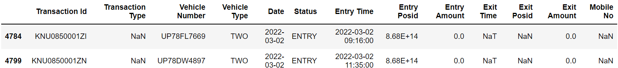**Figure 1 Examples of missing exit time information**

1. Only the 4 entries given below, have blank **Vehicle Type.** (*Figure 2*)

**Example**

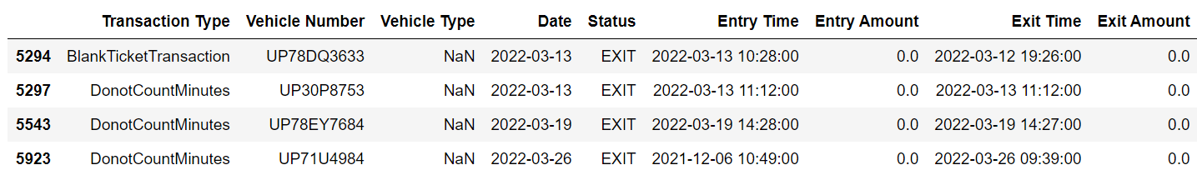**Figure 2 Examples of missing vehicle type**

**2.3.1.3 Time parked is negative.**

We then define a ‘Time Parked’ column, which contains the time difference between exit time and entry time for a ticket (Time Parked = Exit Time – Entry Time), to find the duration a vehicle was parked for. In only 2 entries the exit time was before the entry time or the time parked was negative.

1. Number of inconsistent timings: 2 out of 7612. (*Figure 3*)
2. Hence, in only two entries the **exit time is before the entry time**.

**Example**

**Figure 3 Exit time before entry time**

**2.3.1.4Whether a particular vehicle is termed as only car or bike or both at separate times?**

In 7612 entries, there were 5912 unique vehicles that got parked. Many vehicles visited the parking only once, while many of them visited the parking many times. In 46 cases, the vehicles that visited more than once were marked as 2-wheeler in one entry and 4-wheeler in the other (as shown in the example below). It suggests mistakes in feeding the correct information in the POS device.

The example given below contains three different entries of the same vehicle number, where it is two times marked as 2-wheeler and one time marked as 4-wheeler.

1. 46 vehicles out of 5912 have been marked as **2-wheeler sometimes and 4-wheeler the other**. (*Figure 4)*
2. Also, the charges have been taken accordingly at those times.

**Example**

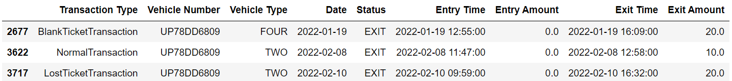**Figure 4 non-uniqueness of vehicle type**

**2.3.1.5 Vehicles having overlapping parked times.**

The example given below has two different entries of the same vehicle, where in one entry it is parked till 22:55 on a date and another ticket of its parking has been generated from 11:33 on the same day. Also, the vehicle has been charged full amount for both entries leading to charging double amount for few hours. In some such cases, one of the overlapping entries is not charged, while in the other ones both are charged.

1. Two or more different entries of a same vehicle have **overlapping "parked time intervals"**, hence they have been charged extra in **some** cases. E.g. A vehicle **charged twice** for the same time.
2. 36 times this mistake has happened. (*Figure 5)*
3. The transaction types in these cases are **all except** Normal Transaction.
4. This happened only in December, January, and February.

**Example**

**Figure 5 Overlapping parked times**

**2.3.1.6 Exit amount differs from the amount expected from time parked.**

We checked whether the exit amount is correct or not as per its transaction type, vehicle type and time parked. In only 50 entries out of 7612, this mistake was found.

In some cases, when a vehicle was parked for exact 5 minutes, it was not charged and the exit amount was zero rupees, while it should have been charged. In some other cases, the time parked for a vehicle was greater than 5 minutes, but it was marked as DoNotCountMinutes ticket and hence no charge was taken.

In some other cases, when a vehicle was parked for 4 hours and one minute, the charge was taken of less-than-4-hour parking, which means half of the actual cost was taken.  
The reasons for how and why all of these happened are mentioned in the below list.

50 Times the **exit amount is different from what is expected** by time parked and transaction type. (*Figure 7)*

Out of 50,

16 discrepancies are because of taking **no charge for exact 5-minute** parkings.

8 times the ticket has been **falsely marked** as DonotCountMinutes.

8 times the ticket has been **falsely marked** as DonotCountMinutes.

4 times incorrect charge has been taken for ‘**just above 4-hour parking**’.

(Remaining) 22 cases happened only on three days of December (10th ,16th and 17th of December) suggesting some fault in POS device, incorrect information fed into the device, revision of the pricing, etc.

4 times the **charge of less-than-4-hours parking has been taken** when the time parked is **just above 4-hours**. In all the four cases, the time parked is exactly 1 minute above 4-hours. These four instances are randomly distributed in December, February, and March. (*Figure 6)*

**Example**

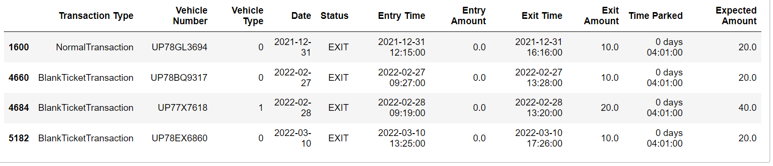**Figure 6 Inconsistency in amount charged**

* The exit amount is **always less** than the expected amount in all the cases.
* The transaction types in these cases are of **all types**.

**Example**

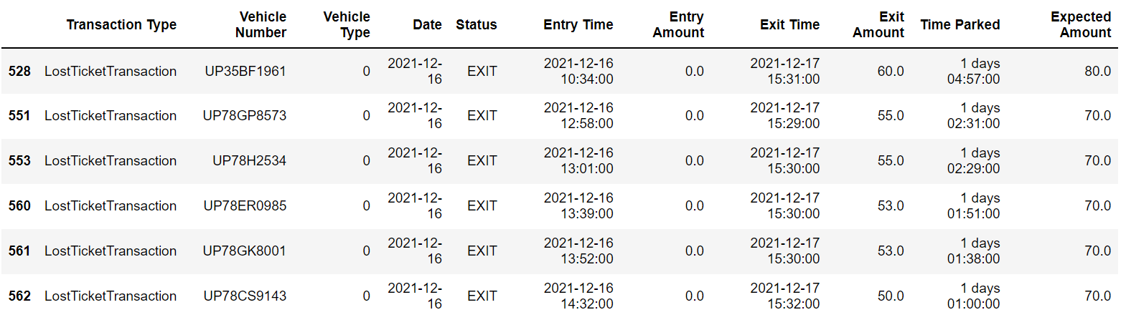**Figure 7 Other instances of mismatch in transaction amounts**

**2.3.1.7 Does the time parked and amount verify what transaction type says?**

We checked whether the transaction type marked is correct or it should have been some other transaction type according to its ‘Time Parked’, ‘Exit Amount’, etc. It happened in some cases that when the parking is for more than or equal to 5 minutes, it was wrongly termed as DoNotCountMinutes and hence no charge was taken.

1. For vehicles parked for **exactly five minutes** (86 times), sometimes charge was taken (70 times) and sometimes not (16 times). Uncharged 5-minute parking tickets were found in all months. (*Figure 8)*

**Example**

**Figure 8 Inconsistent transaction amounts for 5-minute durations**

1. The **penalty of 2 Rupees for Lost Ticket** was taken only in December in 2021.
2. 8 times a ticket has been **falsely marked as** *DoNotCountTicket*. Also, in these cases the time parked is always more than 2 days. (*Figure 9)*

**Example**

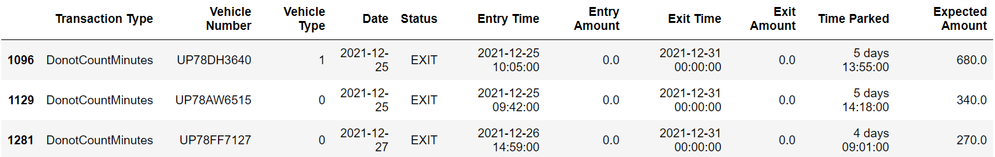**Figure 9 Marking of *DoNotCountTicket***

**2.3.1.8 Date of ‘Entry Time’ column differs from date of ‘Date’ column.**

In significantly many entries the date in the ‘Date’ column is written wrongly as compared to the one written in the ‘Entry Time’ column. Sometimes it is one day ahead, two days ahead, or three days ahead of the ‘Entry Time’ date.

1. 1183 times the **date is written wrongly** as compared to entry time. (*Figure 10)*

**Example**

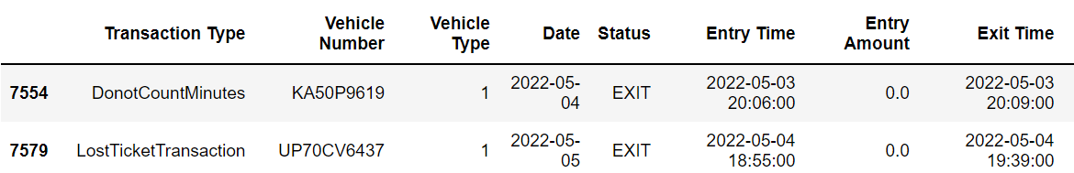**Figure 10 Inconsistency in dates across columns**

1. Out of 1183,

* 1106 times the date mentioned in date column is **1 day** ahead of the date mentioned in Entry Time column.
* 75 times the date mentioned in date column is **2 days**ahead of the date mentioned in Entry Time column.
* 1 time the date mentioned in date column is **3 days** ahead of the date mentioned in Entry Time column.
* The remaining 1 case is shown below. (*Figure 11)*

**Figure 11 Another example of inconsistency in dates across columns**

1. ‘Date’ column had no relation with the date mentioned in ‘Exit Time’ column.

**2.3.2 Exploratory analysis**

Range of the dates used for the analysis:

First date: 2021-12-08 (8th December 2021)

Last date: 2022-05-05 (5th May 2022)

**2.3.2.1 Average number of vehicles parked and visiting on a date of month, a weekday and a specific hour in a day.**

The following plots tell the average number of vehicles that **visited or were parked in that duration**. (*Figure 12)*

The plot for hourly time intervals (at bottom-right corner) is a histogram, while all other plots are bar charts. For finding the traffic in hourly time intervals we calculated how many cars have their parking time interval and a specific hour's time interval having some common minutes or how many cars were parked even for at least minute in that hour. Hence, it gives us a measure of the traffic in that hour, by giving us the sum of the number of cars that were already parked and the number of cars that visited and left during the hour.

Some conclusions:

1. We can expect around eight 2-wheelers and two 4-wheelers to be present at the parking, at the time of midnight.
2. People Park less on Sundays.

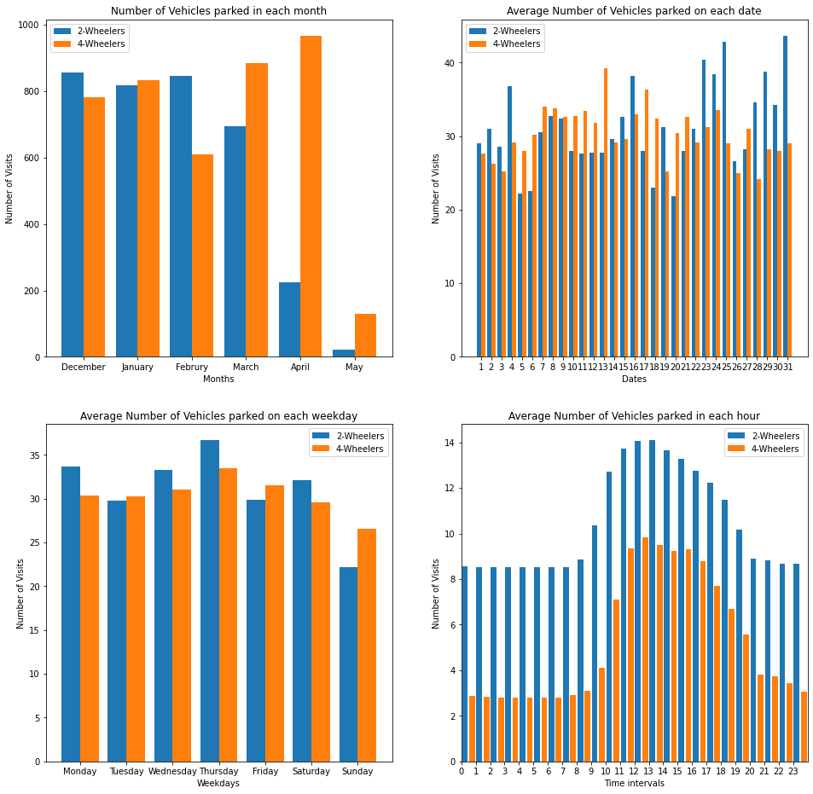**Figure 12 Temporal trends in parking events**

**2.3.2.2 How often people used off-time to enter or exit?**Number of time vehicles that **entered in off-time** (after 10 pm or before 8 am): 79Number of time vehicles that **exited in off-time** (after 10 pm or before 8 am): 67

**Table 4 How often a particular type of transaction happened?**

|  |  |  |
| --- | --- | --- |
| **Transaction Type** | **Number of tickets** | **Percentage (in %)** |
| BlankTicketTransaction | 3421 | 44.94 |
| NormalTransaction | 3140 | 41.25 |
| LostTicketTransaction | 507 | 6.66 |
| DonotCountMinutes | 478 | 6.28 |
| MutilatedOrUnreadableTicketTransaction | 38 | 0.50 |
| Blank/NA | 28 | 0.37 |

**2.3.2.4 Distribution of Time Parked of vehicles.**Time parked Statistics (in hours):

* + Maximum = 2638.833, Minimum = -15.033
  + Mean = 4.297, Median = 1.2

The following are plots (Histograms) showing the distribution of time parked for both type of vehicles, which tells **how many times vehicles got parked for a specific range of durations.** (*Figure 13*) (Example: How many times 4-wheelers got parked for 1 hour to 1 hour and 15 minutes durations?) An example of its conclusions: The vehicles preferred to be parked for 1 to 2 hours than being parked for 4 to 5 hours.

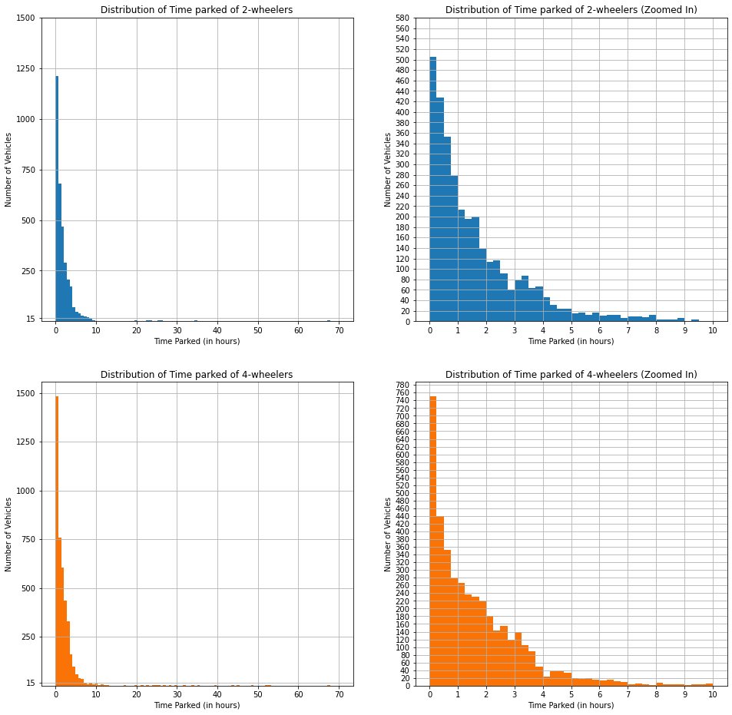  
**Figure 13 Distributions of time parked**

Below are log-plots of distribution of time parked for both kind of vehicles. (*Figure 14)*

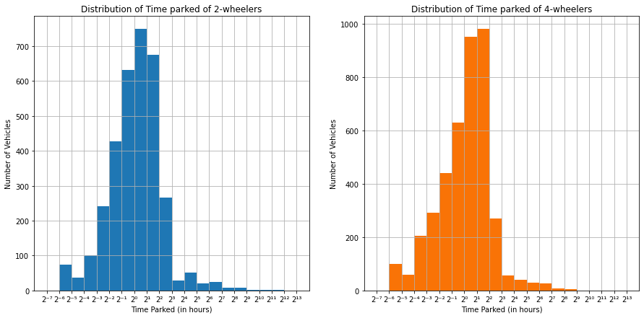**Figure 14 Distributions of time parked (in log scale)**

**2.3.2.6 Average ‘Time Parked’ month-wise.**

The average time a vehicle is expected to be parked for, was found to be dropping month-by-month. (*Figure 15*). Hence, **people parked their vehicles for lesser time in later months**.

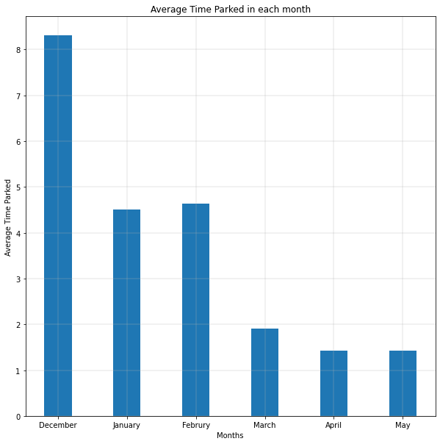  
**Figure 15**Average duration of time parked across months

**Input from KSCL**

**1 Queries over the Codal review**

* Are there any/other specific guidelines and procedures that KSCL follows when identifying and designing on-street parking spots?

**2 Points for clarification over Data Analysis**

* What is a Blank Ticket Transaction?
* Is the parking at Phool Bagh not operational on Sunday?
* How are the entry times of vehicles that entered and the exit times of vehicles that exited in off-time (between 10pm and 8am of next date) are found, if there is no attendant at that time?

**References**

**References for the Codal Review**

**[1]: On-street parking handout, ITDP India**

**[2]: Guidelines on regulation and control of mixed traffic in urban areas (first edition), IRC 2017**

**[3]: Guidelines for parking facilities in urban areas (IRC_SP_12-2015), IRC 2015**

**[4]: IRC:103 - Guidelines for Pedestrian Facilities (Draft), IRC**

**[5]: Complete Street Design workbook, ITDP India, MoHUa, Smart city Initiative India.**